Chapter 16, Solution 63.

Consider the parallel RLC circuit of Fig. 16.86. Find v(t) and i(t) given that
v(0) = 5 V and i(0) = –2 A.

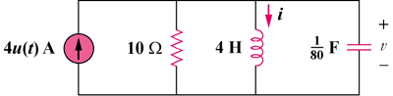

Figure 16.86
For Prob. 16.63.

Solution

The s-domain form of the circuit with the initial conditions is shown below.

-2/s

R

sL

1/sC

4/s

V

I

5C

At the non-reference node,

But ,

, ,

Checking, Ldi/dt = 4{24 e^{–4t}cos(2t) + 12 e^{–4t}sin(2t) + 45.5 e^{–4t}sin(2t)
– 22.75 e^{–4t}cos(2t)}u(t) = [5 e^{–4t}cos(2t) + 230 e^{–4t}sin(2t)]u(t). Answer checks.

